**AA USER LOG-IN**

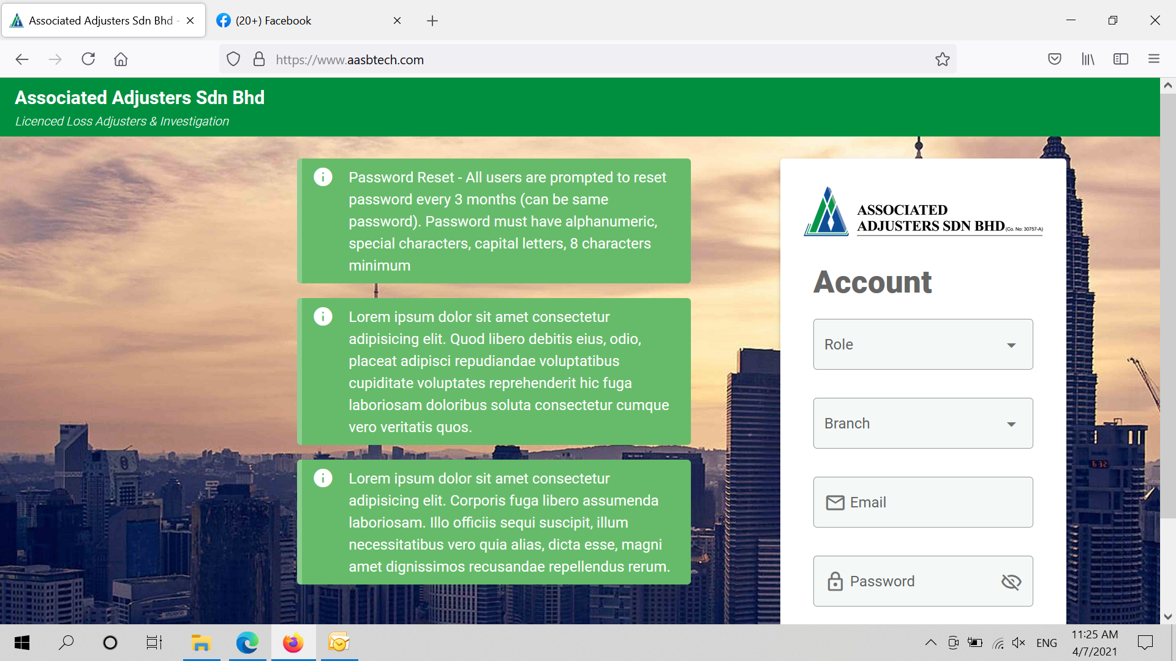

**NOTES FOR DEVELOPER**

1. The user login page should have two sections, one is for the user log-in and the other is the message board.
2. All users will use one single page to log-in.
3. The users should be able to login by entering their Id and password, no other credentials needed during the sign-in. They should not be required to choose their branch, their department or by position.
4. The message board is to display messages posted by the admin. The admin should be able to post and remove messages at given time.

SEE NEXT PAGE FOR – WELCOME PAGE

**WELCOME PAGE**

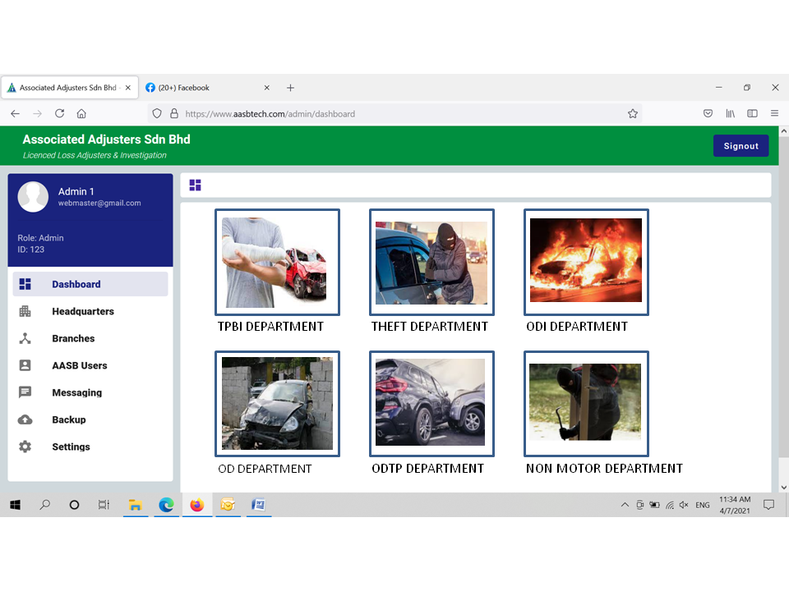

**NOTES FOR DEVELOPER**

1. Once the user logged into the system, they can come to this page – Manager / Editor / Staff / Adjuster, it must be segregated by branches.
2. The respective HQ manager and compliance officer will have access to the branch level. However the branch managers will not have access to HQ level.
3. The users access to the department as per their rights given to them by the admin.
4. There will be a segregation by users

**STAFF / EDITOR / MANAGER – TPBI DEPARTMENT**

1. Staff / editor / manager will be directed to the dashboard of TPBI department (TPBI Department Process Flow)

**ADJUSTERS – TPBI DEPARTMENT**

1. Adjusters will be directed to the dashboard of (TPBI Adjuster Process Flow)

Staffs, editors, manager, adjusters may have access to single or multiple departments. If user has no access to TPBI Department he will not be able to receive or view any TPBI department cases. As such the image may be blurred and not activated by the hyperlink.